Griffin Lehrer Numerical Exam Final

Question 2 Write Up

Using the data table:

|  |  |  |
| --- | --- | --- |
| Planet | Period  (years) | Relative distance  (AU) |
| T1 | 0.242 | 0.388 |
| T2 | 0.616 | 0.724 |
| T3 | 1.00 | 1.00 |
| T4 | 1.881 | 1.524 |
| Gα | 11.86 | 5.20 |
| Gβ | 29.33 | 9.51 |
| Gγ | 84.32 | 19.23 |
| Gδ | 164.79 | 30.10 |

When graphing all the data from the table above using the period as the x values and the relative distance as the y values, we see that the resulting graph looks like this:

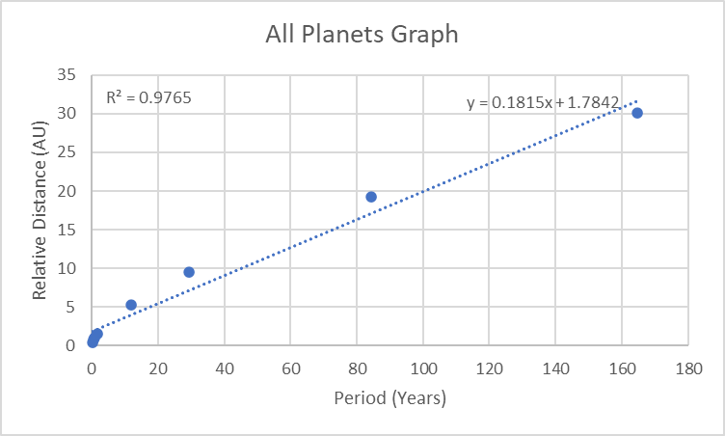

From the graph we can see that the outermost planets (G planets) curve away from the innermost planets (T planets). When using least squares to fit data the algorithm assumes that the data in question is going to be linear. The outermost planets are not linear compared to the innermost planets and this causes the resulting least squares to fit the data less accurately than it could if the data was more linear. In fact looking at a graph of just the innermost planets (T planets):

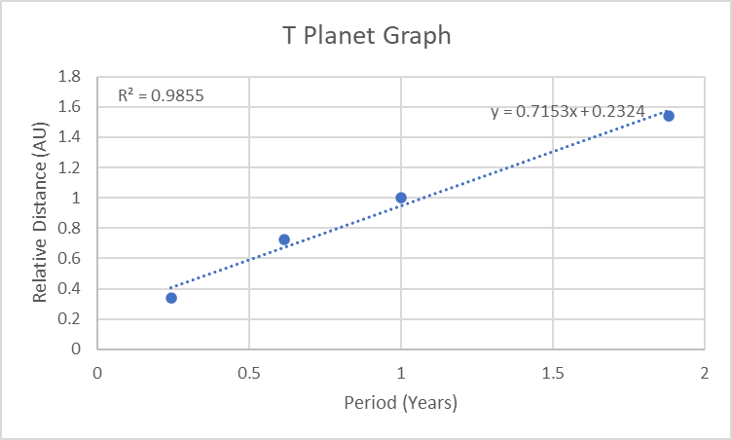

We can see that the data points are much more linear than it was before when including all the data points. We can see that the least squares method fits the data much better than before due to the higher r^2 value. When looking only at the outermost planets (G planets) we can see the graph looks like this:

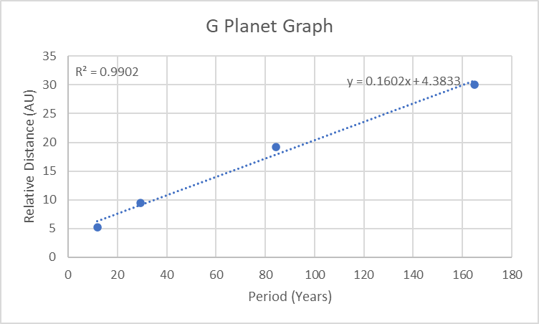

Once again, the data is much more linear than it was before when including all the planetary data. This is reflected in the higher r^2 value. From comparing the innermost planets and outermost planets with all the planets together we can conclude that the data is more linear when we look at them separately. From this we can see that using two different fits one for the innermost planets (T planets) and one for the outermost planets (G planets) will be more accurate than using one fit for all of the data.